**REPORT ANALYSIS**

**TEAM DYNAMOS**

* **Divya Musahib & Durgesh Shukla**

**Hackathon Challenge: In-Depth Tourist Experience Analysis**

* **We are given a dataset of an Airline company consisting of information of their passengers and their feedback & satisfaction from the services.**
* **The data consist of information about** 
  + **Customer Gender**
  + **Customer Age**
  + **Customer Type (returning or first time)**
  + **Ticket Class (Economy, Economy Plus, Business)**
  + **Departure and Arrival of Flight**
  + **Flight distance**
  + **Rating of in-flight services like (Food, Wi-Fi , Seat- Comfort , Entertainment , Baggage Handling )**
  + **and many more…**

**Challenge Questions**

* **Dashboard**

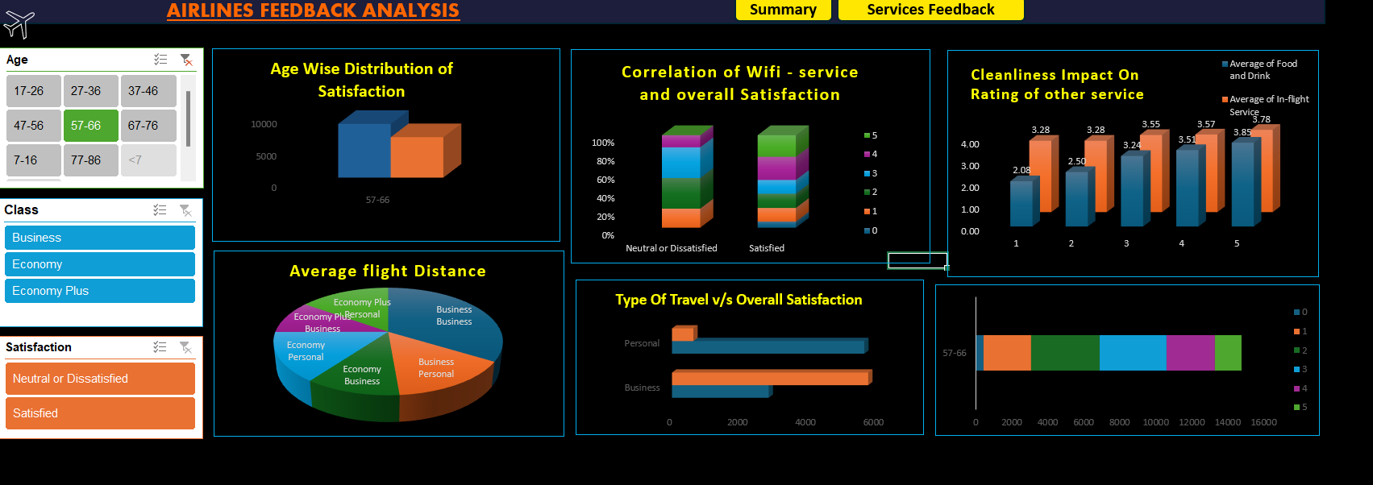

1. **Customer Satisfaction Varies with Age**

* There is a range of different ages of passenger ranging from 7 years to even 86 years
* It is important for the company to keep an eye on how different age groups are satisfied from their services.
* Here is the analysis that how many persons are satisfied age wise from the services  
  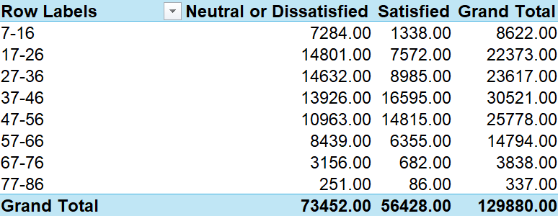

1. **Average Flight Distances Under Different Classes**

* This is the distribution of how different purpose people and different class people travel average flight

**3. Does Type of Travel Affect Customer Satisfaction?**

**Objective**: Is there a correlation between the type of travel (Business, Personal) and the overall satisfaction of customers? Do you see any type of dependency on the type of travel with overall satisfaction of customers?

**4. Impact of Gender on Wi-Fi Service Satisfaction**

**Objective**: What is the relationship between gender and the ratings for in-flight Wi-Fi service? Evaluate the change in ratings over different ages. Do you find any significant changes or observations?

**5. Little Things Matter**

**Objective**: How does the cleanliness rating correlate with other service ratings such as food and drink or in-flight service? Evaluate all the correlations and share your insights about what you find by identifying these correlations.

**BONUS QUESTION ➖>**

-->It will be judged between all the participants….!)

Q.)Find the best insight in the dataset that is both IMPACTFUL and UNIQUE.?